SBABS

#### Project Plan

#### 

#### Team Members:

#### Joseph Olivarez

#### Alaba Olanipekun

#### Jade Gee

#### Makhtar Diop

#### Mary Jones

#### Priyadarshini Thota

#### 

#### 

#### 

#### November 10th, 2021

## Table of Contents 1

**Problem Statement** **2**

**Project Mission Statement** **2**

**Project Objectives** **2**

**Project Work Requirements** **2**

Implementation of Shelterluv software 2

Establish training manual 3

Data entry 3

Volunteer draft documents 4

**Exit Criteria** **5**

**Work Breakdown Structure** **6**

**Milestone schedule** **7**

**Working schedule** **7**

**Required Resources** **9**

**Team members** **9**

**Control system** **1**0

Quality assurance: 10

Conflict resolution: 10

Change control: 10

**Major contributors** **1**1

**Risks** **1**3

## 

## Problem Statement

Spring Branch Animal and Bird Sanctuary (SBABS) relies on a paper filing system. Without an electronic database, simple daily tasks become arduous and tracking rescues and adoptions in real time is impossible. Accounting problems also arise as the organization cannot track the cost of caring for an animal and reconciling these costs with adoption fees and donations collected. Additionally, because of this mode of operations, the organization lacks the time needed to advertise itself or hire and train new volunteers. These issues warrant immediate attention, if things continue on as they were, the organization will have accumulated a greater workload than can be reasonably maintained. In an attempt to remedy these issues, our team will be providing SBABS with a user friendly electronic database that is compatible with window operating systems. The accounting details will be integrated into the database to be developed. For this project, we will customize the database to suit needs specified by the client and assist with the onboarding of volunteers.

## Project Mission Statement

The team’s mission is to implement a user-friendly database that enables SBABS transit from the current paper filing to an online software. The team will also assist in developing custom email drafts that will be used to attract future volunteers.

1. Provide the client with ready software that will be utilized freely with little to no maintenance. The workflow must adhere to all customer requirements to ensure proper documentation of the animal shelter.
2. Generate draft emails the owner will be able to utilize to attract potential volunteers from varying schools or universities. The volunteer forms will attract future volunteers for animal shelter experience and data entry experience.

## Project Objectives

* Decrease the record keeping time-management by at least 20% by transitioning paper documentation to a database software by December 2022.
* Attract 2 volunteers by September 2022 using custom email drafts sent to varying schools for volunteer experience in an animal shelter location.

## Project Work Requirements

###### Implementation of Shelterluv software

* 1. The Shelterluv software will be used to transition from a current paper filing method to an easy to use online software where data is easily accessible at all times.
  2. Shelterluv will provide the owner the ability to store and search all past and present reports at any given time.
  3. The client's computer will be used and must be assessed to meet all software requirements.
  4. Software will have a hard-drive back up in an external drive for any technical issues that may occur.

###### Establish training manual

* 1. The client will need a training manual that does need any technical knowledge or technical background.
  2. The training manual provides the client with instructions on how to access certain key features within the software.
  3. The training manual must consist of some useful shortcuts in the program that the owner will be able to reflect on.
  4. The training will follow an easy to read style, a template will be provided below.

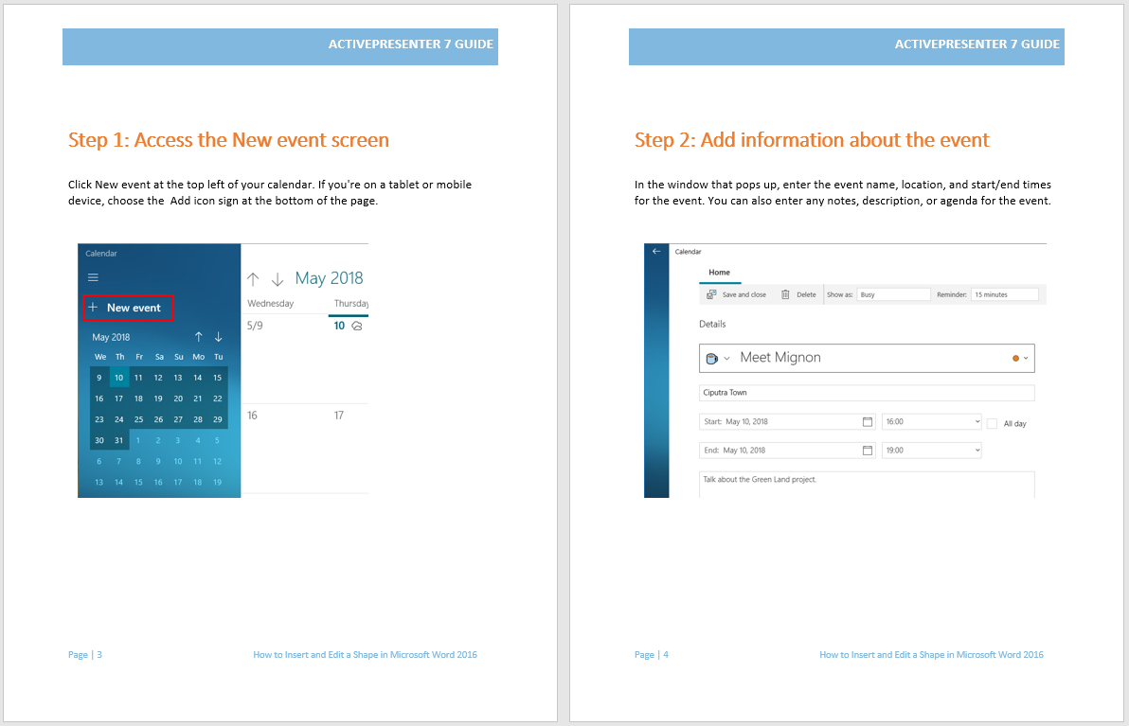

###### Data entry

* 1. Once the Shelterluv software has been installed on the client’s computer, we will assist with organizing the current animals located in the shelter's current filing system.
  2. The data entry will aim to transition all current forms as templates into the database software for the client to use at any time.
  3. All current animal residents at the shelter will be included within the database. All descriptions and pictures will be entered with each animal to ensure correct data management.

###### Volunteer draft documents

* 1. The draft documents will be utilized by email. The drafts must be creative and friendly to all ages as they will be sent to schools in the future.
  2. The drafts must be downloaded as reports within the Shelterluv software. This will allow the completed drafts to be readily accessible and used by the owner.
  3. The drafts will highlight the client’s business needs and be eye-catching with an easy to follow structure for students of all ages.



## Exit Criteria

|  |  |
| --- | --- |
| **Project Milestone** | **Criteria** |
| Software successfully installed on clients computer | The Shelterluv software system passed integration testing and meets the performance requirements within the client’s computer.  The project manager will review the software and ensure no bugs are hindering the program.  The project manager will review the client opening up the software successfully and the installation will be considered a success. |
| Training manual developed | The training manual consists of two main criteria. Client is trained with sufficient knowledge of software and delivery of the training manual to the client.  The project manager will assess the client's knowledge within the software to ensure they are able to enter in the correct data and navigate correctly.  The training manual will be reviewed by the project manager. The owner will review the training manual after an approval has been submitted by the project manager. The manual will then be considered complete and multiple copies will be produced. |
| Completed volunteer documents | The volunteer documents will consist of two main criteria. All drafts email for volunteers have been completed and processed as templates within the shelterluv database. Forms will be readily accessible for potential volunteers to completely fill online.  The project manager will review the submissions; once approved by the project manager it will be reviewed by the client. After receiving approval from the client, the volunteer documents will be considered complete. |
| Preset forms and data entry implemented into the software | After all data entry has been validated it will be reviewed by the project manager. The project manager will ensure all files are up to date with the SBABS in home animals and forms. The client will review the data and assess all the software forms match the current documentation provided by SBABS. Once all data entry is complete the client will have an entry for future adoptions or animals. |
| Final Project complete | After the client has signed off on the final project, the project will be considered a success. The project manager will follow up with the client before the end of December to ensure the software is running correctly. |

## Work Breakdown Structure

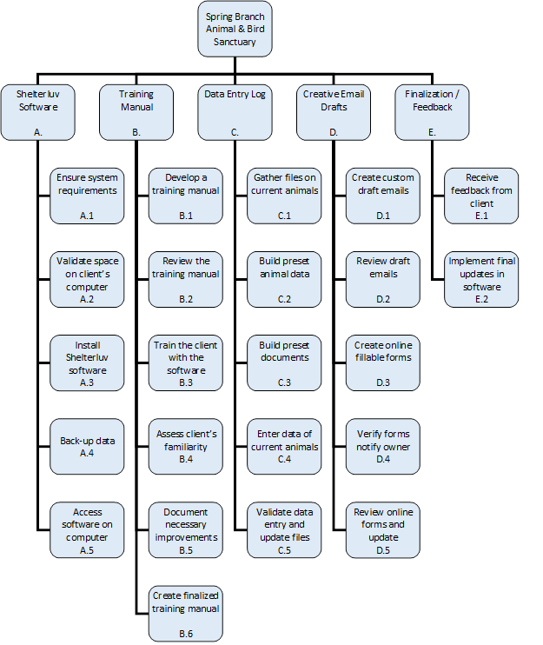

## Milestone schedule

|  |  |
| --- | --- |
| **Project Milestones** | **Estimated Completion Date** |
| Project Plan approved by client | November 12th, 2021 |
| Software successfully installed on clients computer | November 13th, 2021 |
| Training manual developed | November 27th, 2021 |
| Completed email templates | November 28th, 2021 |
| Preset forms and data entry implemented into the software | December 5th, 2021 |
| Final Project complete | December 14th, 2021 |

## Working schedule

|  |  |  |  |  |
| --- | --- | --- | --- | --- |
| **Action Number** | **Action** | **Task Duration**  **(days.hour)** | **Start** | **End** |
| **A.** | Installation of Shelterluv Software | 0.2 | 11/13/2021 | 11/13/2021 |
| A.1 | Check system requirements on clients computer | 0.2 | 11/13/2021 | 11/13/2021 |
| A.2 | Valid space on clients computer for shelterluv software | 0.2 | 11/13/2021 | 11/13/2021 |
| A.3 | Install shelterluv software | 0.2 | 11/13/2021 | 11/13/2021 |
| **Action Number** | **Action** | **Task Duration**  **(days.hour)** | **Start** | **End** |
| A.4 | Assist with backing up data in a external hard drive | 0.2 | 11/13/2021 | 11/13/2021 |
| A.5 | Provide brief overview of how to open and save Shelterluv to the client | 0.2 | 11/13/2021 | 11/13/2021 |
| **B.** | Establish training manual | 7.0 | 11/20/2021 | 11/27/2021 |
| B.1 | Develop a training manual | 4.0 | 11/20/2021 | 11/24/2021 |
| B.2 | Review the training manual | 1.0 | 11/24/2021 | 11/25/2021 |
| B.3 | Train the client utilizing the training manual | 0.4 | 11/24/2021 | 11/26/2021 |
| B.4 | Allow the client to get familiar with the software entering necessary data | 0.4 | 11/24/2021 | 11/26/2021 |
| B.5 | Document necessary improvements for the training manual | 2.0 | 11/24/2021 | 11/26/2021 |
| B.6 | Create finalized training manual in an online format / paper format for future client use | 1.0 | 11/26/2021 | 11/27/2021 |
| **C.** | Data Entry | 8.0 | 11/27/2021 | 12/5/2021 |
| C.1 | Gather the files of current animals present at the shelter | 1.0 | 11/27/2021 | 11/28/2021 |
| C.2 | Create preset animal data (dogs, cats, birds) | 1.0 | 11/27/2021 | 11/28/2021 |
| C.3 | Build preset documents of current paper forms online (Adoption, release, donations) | 1.0 | 11/27/2021 | 11/28/2021 |
| C.4 | Enter data of current animals present at shelter in the software | 8.0 | 11/27/2021 | 12/5/2021 |
| C.5 | Validate data entry with client, update files if necessary | 1.0 | 12/4/2021 | 12/5/2021 |
| **D.** | Volunteer draft documents | 8.0 | 11/20/2021 | 11/28/2021 |
| **Action Number** | **Action** | **Task Duration**  **(days.hour)** | **Start** | **End** |
| D.1 | Create custom draft emails | 4.0 | 11/20/2021 | 11/24/2021 |
| D.2 | Review draft email with clients to suit business needs | 1.0 | 11/24/2021 | 11/25/2021 |
| D.3 | Create online fillable forms for potential volunteers | 8.0 | 11/20/2021 | 11/28/2021 |
| D.4 | Verify online forms will notify owner upon completion | 1.0 | 11/27/2021 | 11/28/2021 |
| D.5 | Review and update online forms | 1.0 | 11/27/2021 | 11/28/2021 |
| **E.** | Finalization / Feedback | 9.0 | 12/5/2021 | 12/14/2021 |
| E.1 | Receive feedback from client | 9.0 | 12/5/2021 | 12/14/2021 |
| E.2 | Final updates on the software | 9.0 | 12/5/2021 | 12/14/2021 |

## Required Resources

* Shelterluv software (Online)
* Training manual template (Online)
* Email letterhead templates for businesses (Online)

## Team members

|  |  |
| --- | --- |
| **Name** | **Initials** |
| Joseph Olivarez | JO |
| Alaba Olanipekun | AO |
| Jade Gee | JG |
| Makhtar Diop | MD |
| Mary Jones | MJ |
| Priyadarshini Thota | PT |

## Control system

###### Quality assurance:

Quality assurance is key to this project. The team must obtain agreement from the client for nearly every major milestone. If the client is unsatisfied with one of the deliverables, the team will rework it until it meets the client’s needs. All team members will be assigned partners as a backup plan to ensure work is being completed in a timely manner. Each milestone, the team will review the schedule with the client to ensure all needs are being met. The main contact at SBABS we will be working with is Gary Foster, the owner.

###### Conflict resolution:

Conflict resolution is the responsibility of all team members. If a team member disagrees with one of the deliverables, a meeting will be requested with the team to review and modify the current plan if necessary. If no agreement has been reached by this time, the "chain of command" will come into play and the project manager will make the ultimate decision. If the problem continues to ensue even after the project manager has made a decision, the decision will be brought to the teacher for further clarification.

###### Change control:

To account for unexpected or revisory changes to the schedule or overall project, weekly check-ins are required by all team members at least thrice weekly on GroupMe. Two of the check-ins will be according to the teams’ schedule, on Thursday and Sunday, the remaining will be a one on one session if needed with the project manager. These check-ins are a formality that assures that all team members remain aware of changes to the project and schedule and have time to alter their own plans and schedules accordingly. Asana will be used for any updates on a specific deliverable that is assigned to a team member. If the change warrants a change in any of the milestones, the project manager will notify the team and review the assigned schedule to delegate necessary changes to the workflow. The last date for any potential updates will be on December 5th, 2021.

## Major contributors

**Linear Responsibility Chart**

Key:

1 = Actual Responsibility

2 = General Responsibility / General Supervision

3 = Must be consulted

4 = Must be notified

5 = Final Approval

|  |  |  |  |  |  |  |  |
| --- | --- | --- | --- | --- | --- | --- | --- |
| **Alpha Reference** | **Project Manager:**  ***Joseph Olivarez*** | **Project Coordinator:**  ***Alaba Olanipekun*** | **Marketing and General Research:**  ***Mary Jones*** | **Content Marketing:**  ***Priya Thota*** | **Developer:**  ***Jade Gee*** | **Software Trainer:**  ***Makhtar Diop*** | **Business Owner:**  ***Gary Foster*** |
| **A.** | **1** |  |  |  |  |  | **4** |
| **A.1** | **1** |  |  |  |  |  | **4** |
| **A.2** | **1** |  |  |  |  |  | **4** |
| **A.3** | **1** |  |  |  |  |  | **4** |
| **A.4** | **1** |  |  |  |  |  | **4** |
| **A.5** | **1** |  |  |  |  |  | **5** |
| **B.** | **3** | **2** |  |  |  | **1** |  |
| **B.1** | **4** | **1** |  |  |  | **2** |  |
| **B.2** | **4** | **2** |  |  |  | **1** |  |
| **B.3** | **4** | **2** |  |  |  | **1** |  |
| **B.4** | **4** | **2** |  |  |  | **1** |  |
| **B.5** | **4** | **2** |  |  |  | **1** |  |
| **B.6** | **5** | **1** |  |  |  | **2** | **5** |
| **C** | **3** |  |  | **2** | **1** |  |  |
| **C.1** | **4** |  |  | **1** | **2** |  |  |
| **C.2** | **4** |  |  | **2** | **1** |  |  |
| **Alpha Reference** | **Project Manager:**  ***Joseph Olivarez*** | **Project Coordinator:**  ***Alaba Olanipekun*** | **Marketing and General Research:**  ***Mary Jones*** | **Content Marketing:**  ***Priya Thota*** | **Developer:**  ***Jade Gee*** | **Software Trainer:**  ***Makhtar Diop*** | **Business Owner:**  ***Gary Foster*** |
| **C.3** | **4** |  |  | **2** | **1** |  |  |
| **C.4** | **4** |  |  | **1** | **1** |  |  |
| **C.5** | **5** |  |  | **2** | **1** |  | **5** |
| **D** | **3** |  | **1** | **2** | **2** |  |  |
| **D.1** | **3** |  | **1** |  |  |  | **3** |
| **D.2** | **4** |  | **2** | **3** | **1** |  |  |
| **D.3** | **4** |  | **1** | **2** |  |  |  |
| **D.4** | **4** |  | **2** |  | **1** |  | **4** |
| **D.5** | **5** |  | **1** | **2** |  |  | **5** |
| **E** | **1** | **2** | **3** | **3** | **2** | **3** | **3** |
| **E.1** | **1** | **2** | **3** | **3** | **2** | **3** | **3** |
| **E.2** | **1** | **2** | **3** | **3** | **2** | **3** | **5** |

## Risks

|  |  |  |  |  |
| --- | --- | --- | --- | --- |
| **Risk** | **Probability** | **Impact** | **Trigger** | **Actions** |
| Team member is unable to assist with project | Medium | High | No communication from a team member for 3 days consecutive days | Assign tasks within Asana visible to all group members. If an extenuating circumstance occurs the assigned backup will be able to update the group on their assigned work schedule updates. |
| Loss of data | Low | Medium | Computer is slowing down, internet is taking longer than expected | Team members will assist the client with utilizing a hard drive as a back up and keep all up to date files saved. |
| Technology constraints | Low | Medium | Out of date system requirements on personal computer, internet bandwidth is not sufficient | The team will ensure the client’s computer meets all system requirements on Asana’s support page. |
| Scope creep | Low | Medium | Database software providing errors on a constant basis to the client | A backup database will be ready. Shelterluv has an integrated transfer we are able to use to import / export the existing files into the new software. Multiple email drafts will be provided to the client to ensure diversity in email drafts. |